Sorting lists with excel
Sarah Cohen, IRE and NICAR, sarah@nicar.org

Sorting lists is one of the most common things you’ll do with a spreadsheet.
In fact, if you master simple formulas, sorting and importing data from the Internet, you may never need to learn fancy spreadsheet techniques.
But sorting is the most dangerous thing you’ll do with a spreadsheet. Although Excel has become far more forgiving in recent versions, it’s still a good idea to get into good habits. They may save you someday.

Save before sorting
Many reporters save each incarnation of a spreadsheet while they’re working on stories.
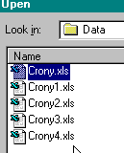Here’s what their choices of files might look like:
Every time they do something they think is a little difficult, they save the file under a new, sequential name.
Saving like this means that, on deadline, you can always get back to the last worksheet you knew was correct. You can always clean out everything but the first and last version after the story’s run or aired.
It’s particularly important to save a new version of your spreadsheet just before you sort. Do it every time, and you’ll never get into too much trouble.
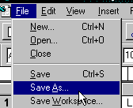To save a new version, choose the menu item File, Save As,
and type in the new name in the box:
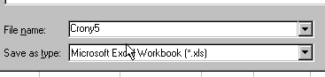

Sorting the NICAR way
Don’t use Excel's quick-sort options; they will backfire occasionally. Instead, select the entire square you want to sort, including any names but excluding column titles. To quickly select a large block of data, first select any cell within the block and then simultaneously press CTL+SHIFT+*. You will see the visible cells become highlighted.. Now hold down the CTL key and hit the period (.) key repeatedly. This takes you to the successive corners of the highlighted text.

This ensures that Excel keeps the rows together. (It usually will anyway, but every once in a while it will screw up – and ruin your spreadsheet in the process.)
Exclude the column headings. You don’t want them mixed in with the numbers.

Sort the rows
Using the menu, choose Data, Sort:
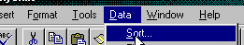
and choose the column you want to sort by:
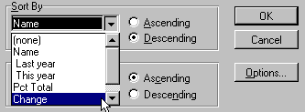
Click once on the column name to lock it into the Sort By box. You’ll usually sort in Descending order, since you want to see the largest value first.
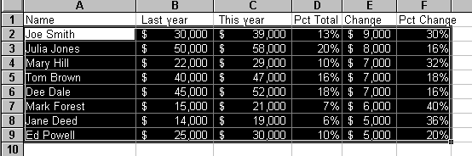

Recovering from mistakes:
If you get something dumb like this:
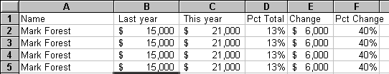
You copied instead of selected.
If it has crazy numbers like this:
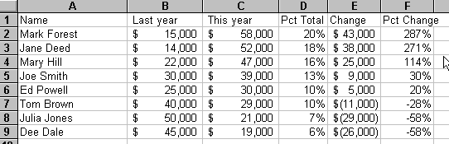
You sorted one column without sorting the rest of each row along with it.

Using the Undo command
In some versions of Excel, you only have one opportunity to recover from mistakes. If you catch it quickly enough, selecting the Edit menu item will give you an option that says, “Undo AutoFill” or “Undo Sort”:
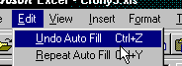
If it doesn’t work, then you have to revert to your most recently saved version.

Recovering a previously saved version
Slow down. Don’t panic. You saved your spreadsheet before you sorted. To recover a previous version, you just have to re-open it.
Choose the menu item, File, Open, and find the correct version. Select it. When you get this message

Say Yes. It will bring you back to that version.

Tips and traps

Set up your spreadsheet with the expectation that you’ll sort it.
- Make sure you can return to the original sort order. Sometimes you’ll have to put a column all the way at the left and enter row numbers.
- Use short titles directly above your data. With this, Excel will show you the names of your columns rather than Column A, Column B, etc.
- Put totals and other summaries at the bottom of your main data, separated with a blank line.
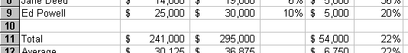
Otherwise you risk mixing them in with the details.

If the selection drops down one line when you start sorting:
This is one of those inconsistent problems. Excel looked at the row just above your sort and tried to figure out if it was a heading. If it guessed incorrectly, it might drop down one row and show you something like this:
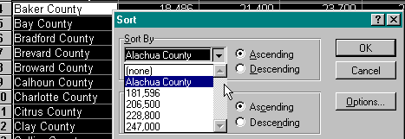
Click the No Header Row at the bottom of the dialog box and choose the column letter instead of a word:


